Zoom Student Instructions

- To start, send an email to writing.center.nyscas@touro.edu

In the subject line, please indicate that you are making a Zoom Session Request and include the date and time.

Please include the following information in the body of your email when requesting a Zoom tutoring session:
- Your full name as written on your student ID
- The time you are available for a Zoom tutoring session
- The class number and location of your class
- The type of assignment and/or instructions for the assignment

Please remember to attach the assignment to the email.

Your email should look something like this:
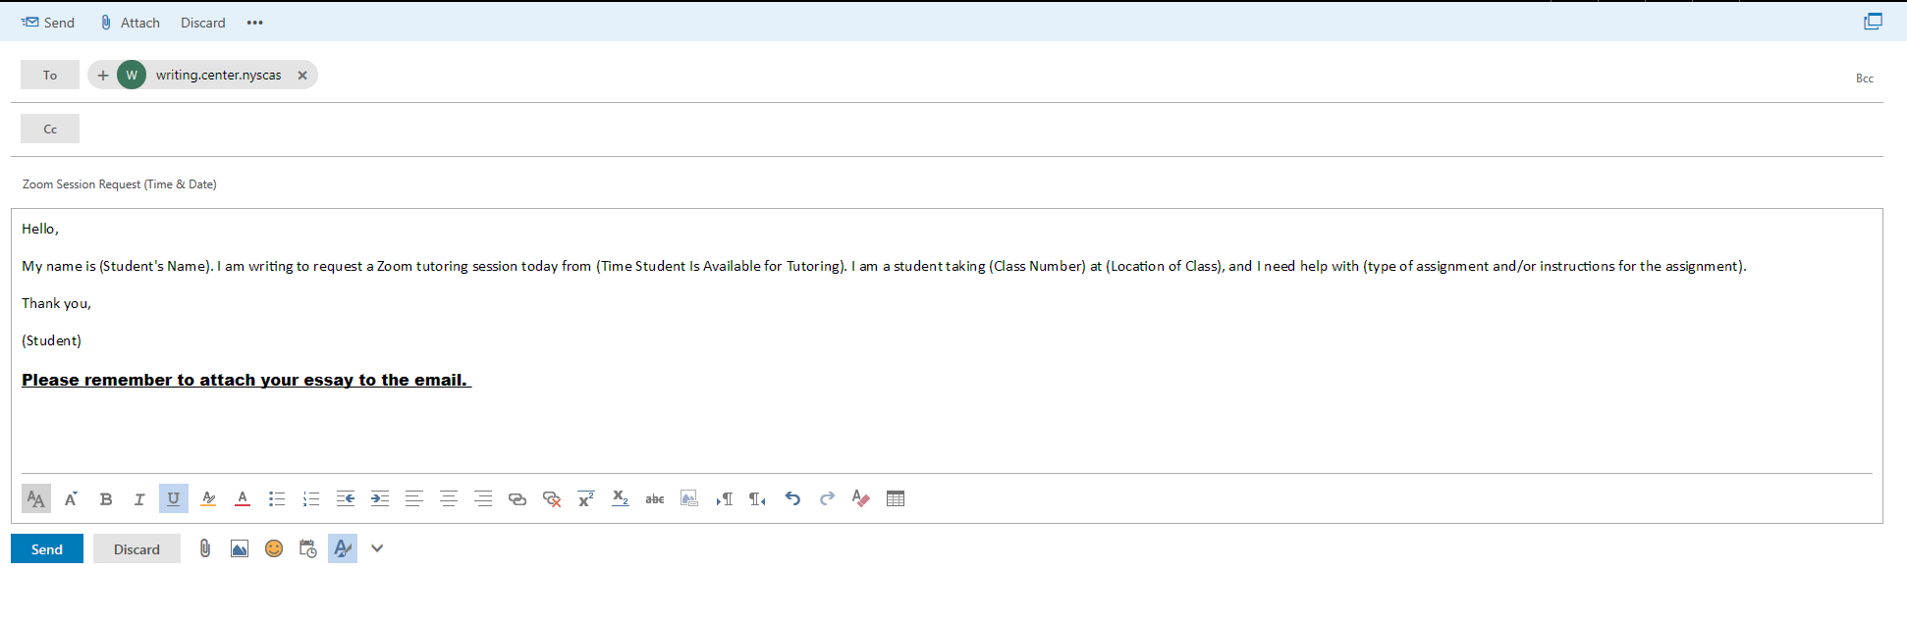

- The tutor will reply to you in a timely manner - within an hour to two hours - with an email that will look like this:

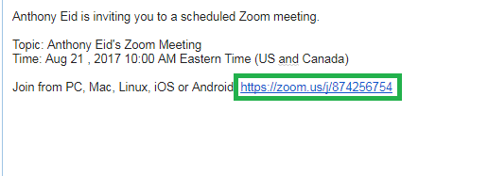

The email will include the tutor’s name, the time and date of the meeting, and the link to the Zoom Meeting. You will need to click on the link (highlighted in the example above) in order to start the process of entering the meeting.

- Once you have clicked on the link, it should send you to a webpage that looks like this:

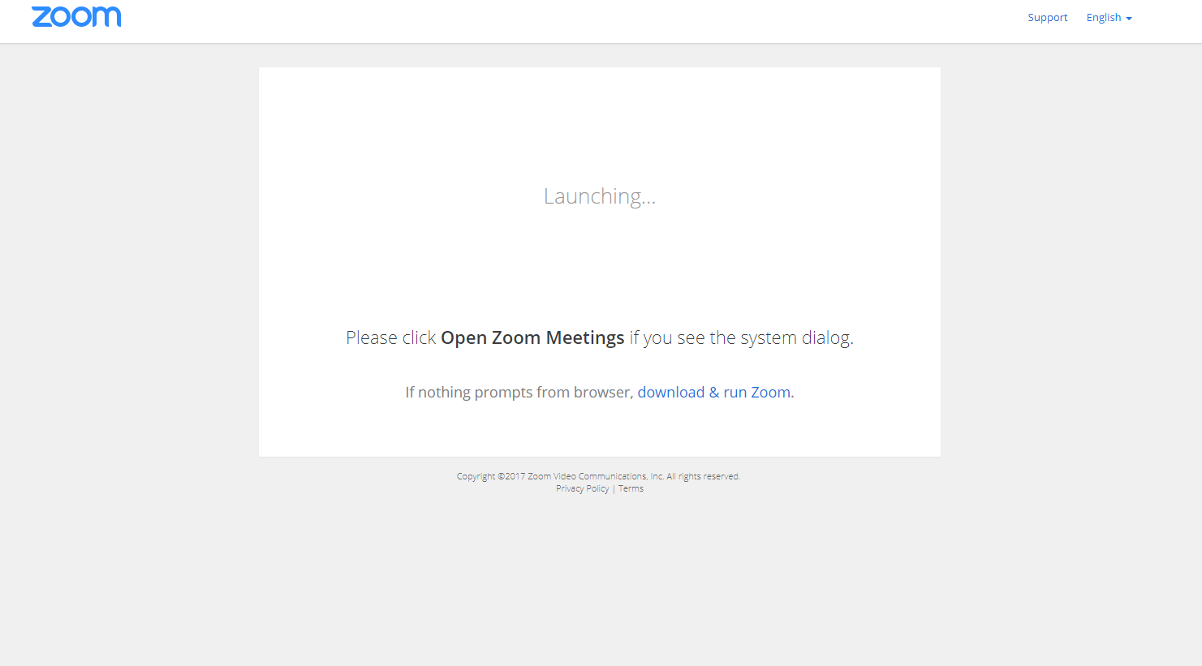

The site will prompt you to download and run Zoom. Once you have done so, the Zoom Client should open to the meeting already started by your tutor.

- When the Zoom meeting opens, it will ask you to join the audio conference. If you have a microphone or webcam, you will be able to talk to your tutor during the session. Please make sure to have your microphone or webcam plugged in prior to opening the Zoom meeting:

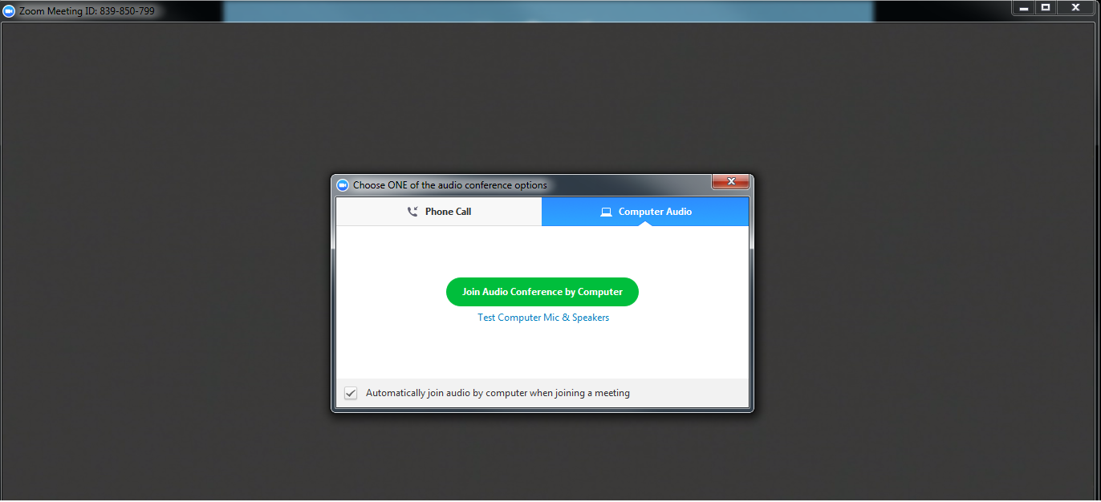

If you do not have Computer Audio – Connected, you have the option of connecting with a phone call. Click Phone Call and dial the number on the screen. You will be prompted for the Meeting ID and the Participant ID, which appear on the screen.
(Continued on the next page.)

4. Continued

OR: If you do not have a webcam or microphone, you have the option to text chat with your tutor while he or she is talking to you over a webcam. In the Zoom client meeting box, there should be a panel towards the bottom of the window. By moving your mouse towards the bottom of the window, new options will show up that will include the Chat option. Click on Chat, and a window with the Zoom Group Chat should appear to the right of the main Zoom meeting window:

Zoom tutoring sessions are available during Writing Center hours:

Monday-Thursday: 10:00am to 8:00pm
Friday & Sunday: 9:00am to 2:00pm

Each session will be 30 minutes long. If the tutor does not have another student waiting to be helped, you may request additional time for your session.

If you need further help for joining a Zoom meeting, please click this helpful link below.

https://support.zoom.us/hc/en-us/articles/201362193-How-Do-I-Join-A-Meeting-

